Designing a website is not just coding. IT's ABOUT PLANNING

DON'T START WRITING CODE BEFORE HAVING AN IDEA OF HOW THE SITE SHOULD LOOK LIKE

DEVELOPMENT PROCESS

## 1. DEFINE THE PROJECT

- define WHO the website is for ==> yourself? A client? Agency ?

- define WHAT the website is for ==> business and user goals

- Business goal: Selling Premium Dog Food

- User goal : Finding High-Quality dog food for good price

- define A TARGET audience ==> be specific if possible and makes sense for your website

- TARGET AUDIENCE: Women, 20-40 yo, livining in Europe, over 2000E/month, passion for dogs

## 2. PLAN THE PROJECT - start thinking about the website

- PLAN AND GATHER WEBSITE CONTENT: copy (Text), images, videos, etc.

- Should be provided by the client

- Plan the sitemap

- what pages the site needs

- how they relate to one another (content hierarchy)

- Plan the sections

- based on the content each section on each page to convey the message to the user

- Define the WEBSITE PERSONALITY

- based on the WEBSITE PERSONALITY framework

## 3. SKETCH LAYOUT AND COMPONENT IDEAS

- Think about what COMPONENTS you need, and how you can use them in LAYOUT PATTERNS (get inspiration in other web designs)

- Get ideas out of your head: VERY VERY IMPORTANT

- PAN AND PAPER - very low fidelity - just some boxes

- Figma (design software)

- Iterative process

- keep experimenting with different components and layouts

- Don't make it perfect from the beginning

## 4. DESIGN AND BUILD

- Use decisions, content and sketches from 1, 2 and 3 and use them to DESIGN and BUILD THE WEBSITE HTML and CSS (designing in the browser)

- We already have the layout and components, so we need to design the actual VISUAL STYLE

- Visual Styles need to be based on the WEBSITE PERSONALITY, design guidelines and INSPIRATION

- use client's branding, if exists - COLORS, TYPOGRAPHY, ICONS

## 5. TEST and OPTIMIZE

- before actual lunch, we need to test and optimize the project

- Ensure the website works WELL IN ALL BROWSERS

- test on ACTUAL MOBILE DEVICES

- OPTIMIZE IMAGES

- right dimensions

- compress them

- Fix ACCESIBILITY (color contrast)

- PERFORMANCE TEST (ligthHouse in Chrome DevTools)

- SEO

## 6. LAUNCH

- share the project with the WORLD

- upload it to a hosting platform

- Free Plan - Netlify

- Buy a DOMAIN NAME - easy to write, memorable, represents the company

## 7. MAINTAIN AND UPDATE

- we need to keep the website content updated over time

- great chance for RECURRING REVENUE

- Install some Analytics SOFTWARE

- Google Analytics

- Fathom

- A BLOG

- a great way to keep users coming back

- great for SEO

# Planning the Actual Website

## Define the project

##### WHO

* For a client – the Omnifood company

##### WHAT

* Business Goal
  + Sell monthly food subscription
* User Goal
  + Eat well effortlessly, without spending a lot of time and money

##### TARGET AUDIENCE

* Technical and Geeky
* Busy people who like technology, are interested in a healthy diet, and have a well-paying job

## Plan the Project – start thinking about the website

##### PLAN AND GATHER WEBSITE CONTENT

* Done, provided by client

##### PLAN THE SITEMAP

* It will be a One Page marketing app (Landing page) , so no sitemap

##### WEBSITE PERSONALITY

* StartUp / Upbeat
* Some elements from Calm /Peaceful

##### PLAN PAGE SECTIONS – Use the website content provided by client

- Navigation (some links at the top to direct users to the sections)

- Hero section

- Featured in section (big logos from other companies)

- How it works

- Diets + Sample meals

- Photo Galery + Testimonials

- Pricing cards + Features

- CTA - Action section (simple form for FREE MEAL)

- Footer

## Sketch the Sections

Navigation (some links at the top to direct users to the sections)

* Logo + Navigation

Hero section

* Image on right
* Headline + Summary on the left

Featured in section (big logos from other companies)

* Logos one next to other

How it works

* 3 Cards
* Each with image and text
* Z Pattern

Diets + Sample meals

* For meals, A card with image on top and meal information below

Photo Gallery + Testimonials

* Testimonials on the left side in a 2x2 grid
* Photo Gallery on the left, with a 3x4 grid

Pricing cards + Features

CTA - Action section (simple form for FREE MEAL)

Footer

Sketch the layout with pen and paper

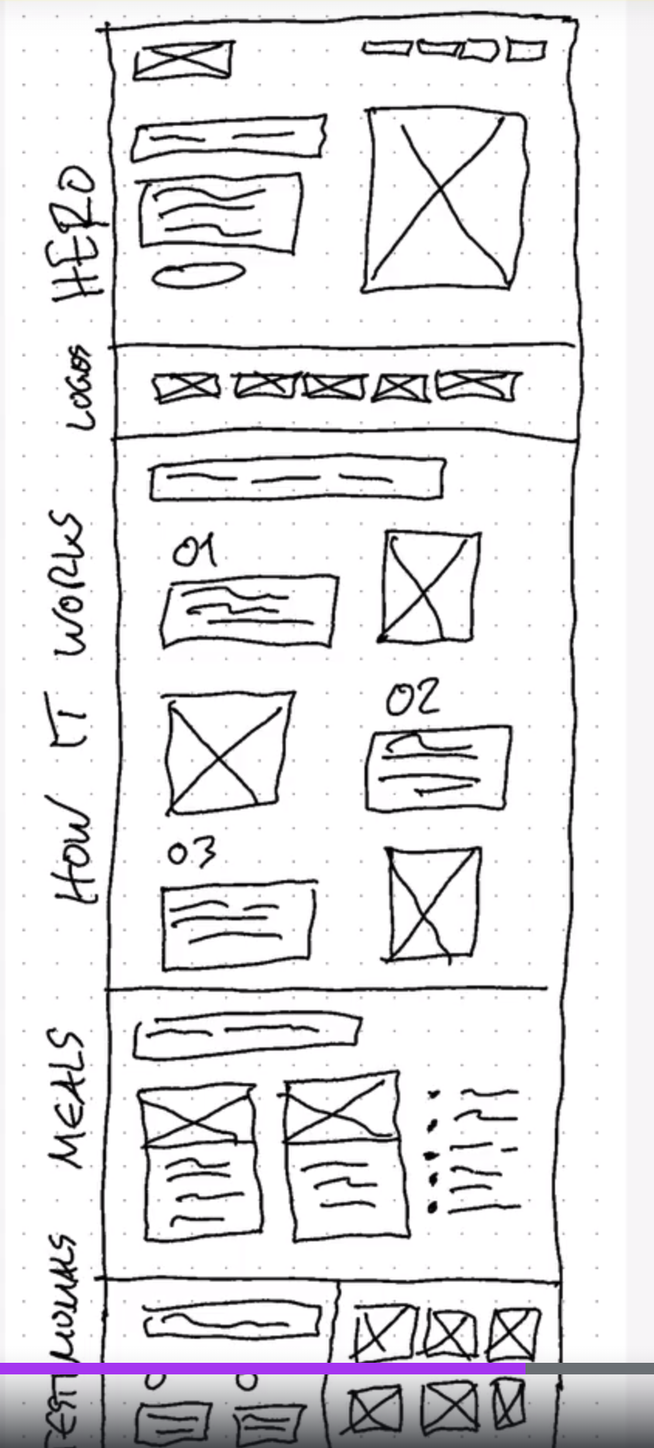

## Build the website and design

* Check each Notes for each section